AIRCRAFT FUEL FLOW MODELING AND PERFORMANCE OPTIMIZATION USING MACHINE LEARNING
Deepak Dharrao1[0000-0002-2540-6942], Mrinank Misal1^{[0009-0006-8681-2705]}, Naivedya Rai1 ^{[0009-0002-0264-0266]}, Nirgoon Joshi1 ^{[0009-0003-5844-9775]}, Siddharth Rajagopalan2 ^{[0009-0004-8732-416X]}, Anupkumar M Bongale3^{[0000-0002-5897-0283]}
¹Department of Computer Science and Engineering, Symbiosis Institute of Technology, Symbiosis International (Deemed University), Pune, India
²Department of Information Technology, Symbiosis Institute of Technology, Symbiosis International (Deemed University) Pune, India
India
³Department of Artificial Intelligence and Machine Learning, Symbiosis Institute of Technology, Symbiosis International (Deemed University) Pune, India
deepak.dharrao@sitpune.edu.in
Abstract. The modeling of fuel flow in aircraft is a critical element in evaluating their performance. However, many of the existing approaches rely on highly aggregated data, which may not provide the necessary accuracy required by the aviation industry. To address this challenge, a new data-driven approach is proposed in this study. This method leverages machine-learning techniques and uses full-flight data from aircraft sensors to develop fuel flow models. The approach focuses on identifying the features that impact fuel flow rates during different flight phases, using a unique deep-learning approach for modeling. The results demonstrate a significant improvement over traditional practices, providing a more comprehensive and accurate alternative for performance evaluations. As a result, airlines and maintenance providers can optimize their operations and reduce fuel costs while meeting environmental targets. The proposed method achieved a 99.25% adjusted R2 score, highlighting the potential of machine learning tools in developing accurate and detailed fuel flow models based on full-flight data, providing significant benefits for the aviation industry.

Keywords: Optimization of Airline Operations, Fuel Flow Models, Full-Flight Data, Multi-Layer Perceptron(MLP), Fuel Consumption and Emissions

- Introduction
Aircraft fuel mileage[1] and fuel efficiency are crucial factors that influence the design and operation of modern airplanes [2]. Fuel efficiency is defined as the amount of fuel consumed per unit of work done, typically measured in terms of distance traveled[3]. The higher the fuel efficiency of an aircraft, the more economical it is to operate. The fuel mileage of an airplane can be determined by calculating the specific fuel consumption [4] (SFC) of the engines. SFC is defined as the amount of fuel consumed per unit of thrust produced by the engine, typically measured in terms of weight.

The formula for calculating SFC is provided in equation (1):

SFC = Fuel Flow Rate / Thrust (1)
Where, Fuel Flow Rate = the rate at which fuel is consumed by the engine, typically measured in pounds per hour, Thrust = the amount of force generated by the engine, typically measured in pounds.

To improve fuel efficiency, aircraft designers and operators employ a range of strategies, including the use of more efficient engines, improved aerodynamics, and lighter materials. Additionally, pilots can optimize fuel consumption[5] during flight by flying at optimal altitudes and speeds, and by minimizing unnecessary weight. By optimizing fuel efficiency, aircraft can reduce their carbon footprint and operating costs, while enhancing their overall performance and competitiveness in the aviation industry.
True Air Speed can be calculated simply from Indicated Air Speed or Mach Number, Pressure Altitude, and Outside Air Temperature. An engine manufacturer provides the fuel flow rate for an engine corresponding to the level of thrust that needs to be generated. However, the fuel flow values are dynamic and vary according to several factors in each phase of flight. Hence, this study will be focusing mainly on fuel flow[6].
The total fuel flow rate of an aircraft refers to the amount of fuel being consumed by the engines in a given period of time, typically measured in pounds per hour or kilograms per hour[7]. It is an important performance parameter that affects the range, payload capacity, and fuel efficiency of an aircraft. It is traditionally understood that factors that influence fuel flow rate include aircraft weight, engine thrust, EGT, pressure altitude, airspeed, ambient temperature, the energy content of the fuel used, aircraft’s center of gravity, and electrical and pneumatic loads. Thus, fuel flow rates are not easy to predict[8].
Fuel consumption[9] is a significant operating cost for airlines, accounting for about 30% of their costs. To improve profitability and reduce their impact on the environment, airlines are implementing fuel efficiency programs. Accurate fuel flow predictions are crucial for budgeting and planning [19]. Flight Dispatch plays a vital role in optimizing fuel usage, providing pilots with the most accurate predictions for fuel consumption. Increasing fuel flow compared to book values indicates deteriorating fuel efficiency, which requires preventive maintenance actions. Proper fuel planning is necessary to avoid carrying excessive fuel and reduce fuel consumption[10].
Every aircraft manufacturer and airline is capable of extracting actual aircraft parameters from aircraft Condition Monitoring Systems (ACMS) and Digital Flight Data Recorders (DFDR). Direct correlation of individual parameters[11] affecting fuel flow through simple data studies is difficult due to the varying flight conditions, flight phases, and vast amounts of generated data. In fact, most aircraft performance monitoring programs only focus on the cruise phase[12] of flight to extract stable flight data including fuel flow rates for analysis. Hence, accurate determination of fuel mileage for all phases of flight is difficult. It is also difficult to determine if the fuel mileage is optimum or not.

There are seven phases of flight - (1) Pre-flight (2) Taxi (3) Take-off (4) Climb (5) Cruise (6) Approach (7) Landing and Rollout
The drivers of aircraft fuel consumption [13]as traditionally understood such as weight, engine thrust, etc. have been stated earlier. However, as the drivers of fuel flow may tend to be different in different phases of the flight, it is important to understand how fuel flow patterns behave in each phase, not just in the cruise phase[14]. There is thus a need to identify actionable insights from modeling analysis[15], to predict the fuel flow rate of airplanes during different phases of a flight (Taxi, Takeoff, Climb, Cruise, Approach, Rollout).

- Literature Review

Table 1. Literature Review
Paper Details | Strengths | Observations
Managing Fuel Efficiency in the  Aviation Sector: Challenges,  Accomplishmentsand Opportunities [2] | A global consensus is crucial to attain aviation's goals of a 1.5% annual fuel economy rise and a 50% cut in carbon emissions by 2050 [2]. Long-term benefits must outweigh immediate gains, necessitating collective efforts for increased fuel efficiency[2]. | Prominent challenges include varying regional commitments, environmental uncertainty, and swift aviation expansion outpacing efficiency gains. Capital-intensive infrastructure upgrades, limited space availability, and high costs curb aviation fuel efficiency.
Modeling of aircraft fuel consumption using machine learning  Algorithms [1] | This research contributes by innovating predictive fuel usage tools [17] and enhancing aircraft fuel efficiency evaluation. Ryerson's study reveals that neglecting unused gasoline increases flight fuel burn by 2-4.5% [18], impacting overall consumption (trip fuel). | This study employs machine learning to simulate aircraft fuel consumption using data [20] from diverse flight stages and missions. Non-parametric methods—decision trees and neural networks—are applied and compared on publicly available flight operation data
Future directions of fuel efficiency in aviation industry [20] | Fuel expenses, highly influenced by fluctuating oil prices, constitute a significant airline cost. Consequently, fuel efficiency is a prime factor in new machinery acquisition, ensuring future profitability amidst environmental and financial concerns. | Fuel consumption reduction ranks high among aviation industry priorities, evident in modern aircraft's lightweight design and low fuel consumption.
Improving airline fuel efficiency via fuel burn prediction and uncertainty estimation [21] | For international flights, evaluating 4D-TP performance can involve using generative adversarial networks to create oceanic routes. This research enables improved route planning and fuel efficiency by forecasting flight paths and drag coefficients. | The airline industry has seen remarkable growth recently. However, congested air routes lead to unintended delays, increased fuel consumption [24], and heightened greenhouse gas emissions. This study proposes a dynamic planning method for optimal flight routes.
Information Analysis Of Modifications To Increase Fuel Efficiency In Regional  Passenger Jets  [23] | Existing and operational commercial airplanes undergo fuel efficiency assessments. Aircraft from the Soviet era consume approximately 1.5 times more fuel than contemporary Boeing and Airbus counterparts in the same class. | Fuel efficiency is a pivotal factor in evaluating passenger aircraft efficiency. Several elements impact fuel economy, including aircraft design, compliance with safety and environmental standards, and operational economics, all of which strongly influence airline profitability.
Fuel consumption optimisation using structural equation modelling and  genetic algorithm approach: The case of commercial aviation[26] | Potential future research directions could encompass previously unexplored variables. Currently, 66% of participants were academics; expanding the sample size to include more aviation industry professionals could yield a more precise FCO model. Incorporating advanced techniques such as hybrid algorithms, ant colony optimization, bee colony optimization[26], and real-coded GA could bolster FCO. | To address this, structural equation modeling (SEM) is employed to develop a model encompassing numerous factors affecting civil aircraft fuel consumption [28]. Through 249 questionnaires distributed to aviation specialists, decision variables strongly linked to various dimensions are identified. SEM outcomes reveal four key factors positively impacting fuel consumption and optimization.
Flight Time Prediction for Fuel Loading Decisions with a Deep Learning Approach[18] | Positive outcomes [29] showcase the potential of employing deep learning for improved flight time estimates and fuel loading policies. Future efforts aim to boost model performance on majorly delayed flights, while maintaining acceptable error levels for regular flights to refine fuel loading policies. | This paper introduces a novel spatial weighted recurrent neural network model to enhance nationwide flight time predictions, utilizing data from sources. Long short-term memory[16] networks are employed after the spatial weighted layer to refine predictions.
Evaluating fuel consumption for continuous descent approach based on QAR data[17] | This study aimed to assess fuel savings potential for the continuous descent approach. Utilizing historical QAR data, a sub-match method was proposed, replacing mathematical modeling [17]. Various parameters were employed to determine flight conditions' sub-conditions, showing a mean error of under 3%. | When evaluating current and prospective civil aviation technologies, fuel conservation is a pivotal factor. The Continuous-Descent Approach (CDA), as an innovative concept, demands a method for assessing its fuel efficiency. However, validating the appropriateness of previous fuel consumption methods remains challenging due to limited operational data.

- Method
  - Dataset

Description

The dataset consists of 63 features obtained from the flight[30] data recorder of an aircraft, which are used to predict the fuel flow rate. The dataset includes various flight parameters such as control columnClick or tap here to enter text. position, aileron position, elevator position, flap position, spoiler deploy status, tail antice, total air temperature, thrust mode, and wind speed, among others. The dataset also contains some derived parameters such as pressure altitude, ground speed, true airspeed, and inertial vertical speed. The dataset includes parameters related to aircraft motion, such as roll angle, vertical acceleration, and lateral acceleration. In addition, the dataset contains parameters related to the aircraft's environment, such as wind direction and temperature.

The dataset provides a comprehensive set of features for modeling the fuel flow rate of an aircraft, and the parameters cover a wide range of flight conditions and phases. The dataset is suitable for training machine learning models for predicting fuel flow rates and can be used to enhance the efficiency of aircraft operations.
Data Collection. The Flight Data Recorder (FDR) data was obtained for analysis, which contained nearly 11 million records and 226 features. Only attributes relevant to the analysis were selected in consultation with domain experts, and the number of features was reduced to 63.

Data Cleaning. Data cleaning was performed to prepare the dataset for analysis. Duplicate values, missing values, and logical errors, including outliers, were dealt with by applying various techniques such as imputation, removal, and statistical methods. After this process, a clean and curated dataset called the Analytical Base Table (ABT) was obtained.

Exploratory Data Analysis (EDA). Exploratory data analysis was performed to better understand the dataset. The impact of different features on the target variable was examined, and potential solutions to reduce fuel consumption during various flight phases were discovered. The correlation between different features and the target variable was analyzed, and visualization techniques were used to uncover hidden insights and patterns in the data.

Data Modelling. For modeling, the data was split into three sets: training, testing, and validation. Multiple base models were created using various machine learning algorithms such as Decision Trees, Random Forests, and Neural Networks. Hyperparameter tuning was performed using cross-validation techniques to fine-tune the models. Afterward, the performance of the models on the testing dataset was compared, and the model with the highest accuracy was selected for further analysis.

Comparative Analysis. In this stage, a comparative analysis was conducted of the solution with existing solutions in the industry. The performance metrics were thoroughly examined, and the strengths and limitations of the model were evaluated. The model outperformed existing solutions in several areas, including accuracy, efficiency, and ease of use. Some areas were identified where the model could be improved, such as expanding the dataset and fine-tuning the algorithms. Despite these limitations, the model provides a significant improvement over existing solutions and offers promising potential for future research. In conclusion, it is believed that the solution offers a valuable contribution to the industry, and it is hoped that it will be further refined and improved in future research.
  - Block Diagram Flow
The architecture of the system is presented in Figure 1, which explains the various phases of the proposed system.

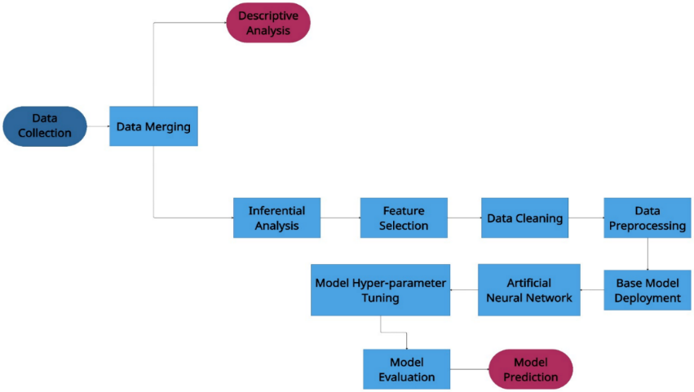
Fig. 1. Flowchart of the AI-based models and experimental methods applied

Acquisition of Data. The initial phase entails the systematic collection of pertinent datasets from diverse sources. This stage ensures the availability of a comprehensive and representative dataset for subsequent analysis.

Integration of Data. Following data acquisition, the obtained datasets are amalgamated and merged to create a unified dataset. This amalgamation process ensures the consolidation of information from multiple sources, enabling a holistic analysis.

Explanatory and Inferential Examination. Subsequently, a thorough analysis of the merged dataset is conducted. Descriptive statistics offer an overview of the dataset's characteristics, while inferential analysis encompasses hypothesis testing and deriving meaningful insights from the data.

Selection of Features. To streamline subsequent analysis and optimize model efficiency, a prudent selection of relevant features is undertaken. This process involves identifying and retaining the most influential variables that significantly contribute to the research objectives.

Cleansing of Data. The dataset undergoes meticulous data cleansing procedures. This phase involves detecting and rectifying discrepancies, inaccuracies, and absent values within the dataset, ensuring the integrity and quality of the data.

Data Preprocessing. The preprocessed dataset is then subjected to normalization, scaling, and transformation to enhance model convergence and performance. This phase prepares the dataset for subsequent modeling[25].

Implementation of Baseline Model. Initially, a foundational model is deployed using traditional machine learning techniques. This model serves as a reference point for more intricate models, aiding in gauging their relative performance.

Utilization of Artificial Neural Networks. The research methodology incorporates the application of an Artificial Neural Network (ANN) to capture intricate relationships within the dataset. The ANN, inspired by neural networks in the human brain, excels at capturing complex patterns and dependencies.

Evaluation of Models. After deploying the ANN and baseline model, a comprehensive evaluation is conducted. Metrics like accuracy, precision, recall, and F1-score are employed to assess model performance and identify potential areas for enhancement.

Predictive Modeling. The final phase entails employing the trained models for predictive tasks. Employing new, unseen data, the models generate predictions[22], offering insights into future trends, patterns, or outcomes based on the acquired knowledge within the dataset.

- Deep Neural Networks
Deep Neural Networks (DNNs) are a kind of neural network that has several interconnected layers of neurons. In a DNN, each neuron in a particular layer is fully connected to every neuron in the previous and succeeding layers. The input layer takes in the data, which is then propagated through the hidden layers, where each layer applies a nonlinear transformation to the input before passing it to the next layer. The final layer, which is the output layer, provides predictions or classifications for the input data .

The mathematical equation that describes a DNN is in Equation (2):

Y = f(W*X + B) (2)

where X represents the input data, W is the weight matrix that links the layers, B is the bias vector, f is the activation function that introduces non-linearity to the model, and Y represents the network's output. Depending on the problem and data characteristics, the activation function can be a variety of functions such as the sigmoid, ReLU, or tanh function.

Training a DNN involves optimizing the weights and biases to minimize a cost function that calculates the difference between the predicted output and the true output as shown in figure 2. Backpropagation is typically used for this purpose, which is a technique that computes the gradient of the cost function with respect to the weights and biases and modifies them in the direction of the negative gradient using an optimization algorithm such as stochastic gradient descent (SGD). To prevent overfitting and enhance the model's generalization performance, regularization techniques like L1 and L2 regularization can also be employed.

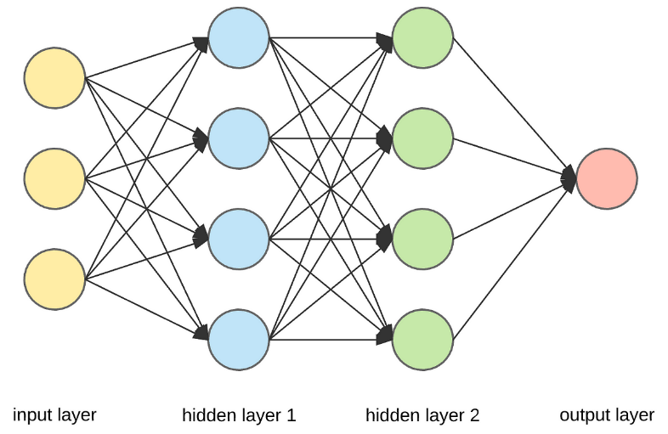
Fig. 2. Deep Neural Network
- Exploratory Data Analysis
Analysis – Phase wise FF rate as shown in Figure 3. Analysis provides valuable information on potential optimization strategies to reduce fuel consumption during different flight periods. The fuel flow rate during the pre-flight phase is relatively low, indicating that this phase has little effect on fuel consumption. However, the taxi, after observing a large amount of fuel flow, indicated the potential for fuel savings through optimization. Possible strategies to reduce fuel consumption [27] during taxis include reducing taxi times or using electric taxis.
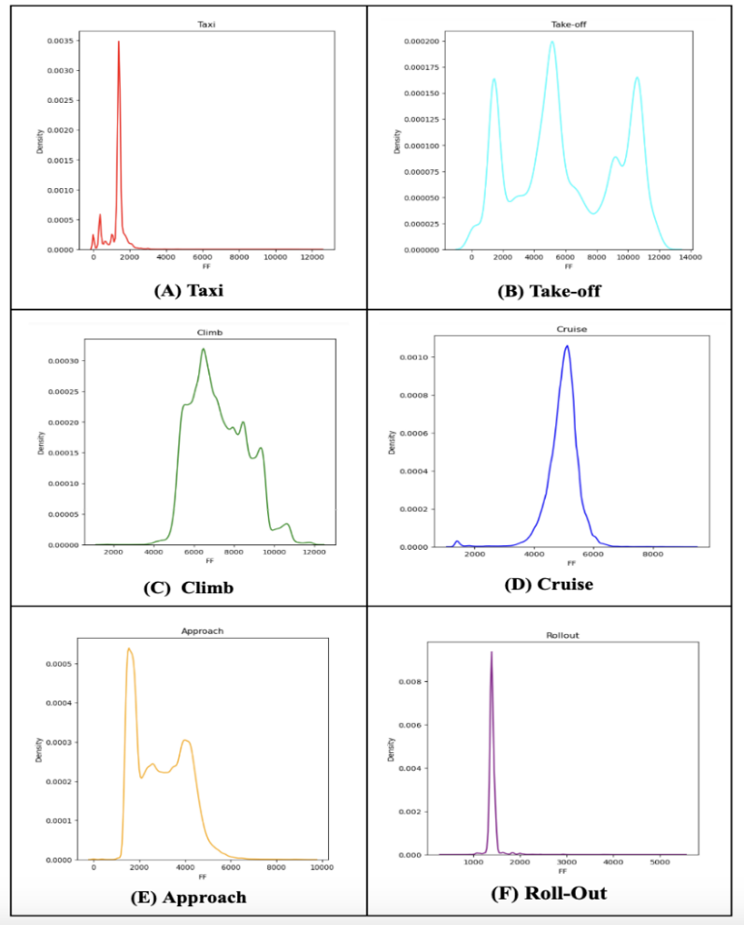

Fig. 3. Aircraft flight Average FF Phase-wise rate
- Taxi (B) Take off (C) Climb (D) Cruise (E) Approach (F) Rollout

High fuel flow rates are observed during the takeoff phase, indicating the potential for significant fuel savings through optimization. Optimization strategies that can reduce fuel consumption during takeoff include optimizing takeoff weight or reducing the thrust setting.

During the climb phase, a relatively stable and lower fuel flow rate is observed, indicating efficient engine performance. Optimization strategies for this phase may include optimizing the thrust setting and the climb rate.

During the cruise phase, a lower fuel flow rate is observed compared to other phases, indicating that efficient engine performance can be maintained during this phase. Possible optimization strategies may include optimizing the cruising altitude and speed.

In the approach phase, a moderate fuel flow rate is observed, indicating the potential for optimization to reduce fuel consumption. Possible strategies may include optimizing the descent rate and approach speed.
During the rollout phase, a relatively low fuel flow rate is observed, suggesting that this phase has a minimal impact on fuel consumption. Possible optimization strategies may include optimizing the taxi route to reduce the time spent on the runway.

In conclusion, significant fuel savings can be achieved by implementing optimization strategies such as minimizing taxi time, optimizing takeoff weight, reducing the thrust setting, optimizing cruising altitude and speed, optimizing descent rate and approach speed, and optimizing the taxi route. These strategies are not only environmentally beneficial but also economically beneficial for the airline industry.

Analysis – MACH Speed Vs Fuel Flow is shown in figure 4. In this analysis of MACH speed versus fuel flow rate from figure, important insights were obtained for optimizing fuel consumption during each phase of flight. During pre-flight, no optimization strategies can be inferred from this phase since the MACH speed is 0.

During taxi, the operator can optimize fuel consumption by reducing engine power during taxiing since the MACH speed is relatively low. The takeoff phase has a significant impact on fuel consumption, with a significant increase in MACH speed. To optimize fuel flow rate during takeoff, proper aircraft loading should be ensured, the most efficient engine thrust setting should be used, and takeoff distance should be minimized.

During the climb, the MACH speed continues to increase, and optimization strategies include using the most efficient engine thrust setting and adjusting the BAV setting based on the current MACH speed. The cruise phase has a relatively high and stable MACH speed, and the operator can optimize the fuel flow rate by maintaining a steady altitude and airspeed, minimizing drag, and using the most efficient engine thrust setting.

In the approach phase, the MACH speed is variable, and optimization strategies include using the most efficient engine thrust setting and adjusting the BAV setting based on the current MACH speed. The MACH speed is low during rollout, and optimization strategies include reducing engine power during rollout to minimize fuel consumption.

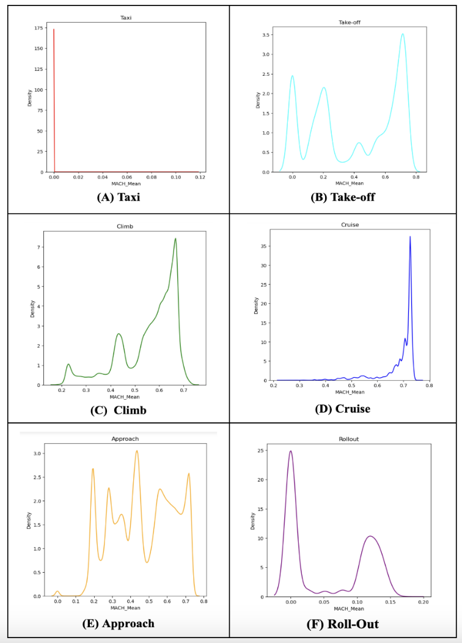
Fig. 4. Aircraft flight Phase-wise MACH Speed vs Fuel Flow rate
(A)Taxi (B) Take off (C) Climb (D) Cruise (E) Approach (F) Rollout

Overall, to optimize fuel flow rate throughout all phases of flight, adjustments to engine thrust and BAV settings based on the current MACH speed should be considered, as maintaining a steady altitude and airspeed, minimizing drag, and ensuring proper aircraft loading.

Analysis – Bleed Air Valves vs FF is shown in figure 5 and 6. The relationship between Bleed Air Valves (BAV) and Fuel Flow (FF) during various phases of flight was analyzed. A negative correlation between BAV and FF was revealed in Figure 5(a), which was further investigated during the climb phase of the flight.

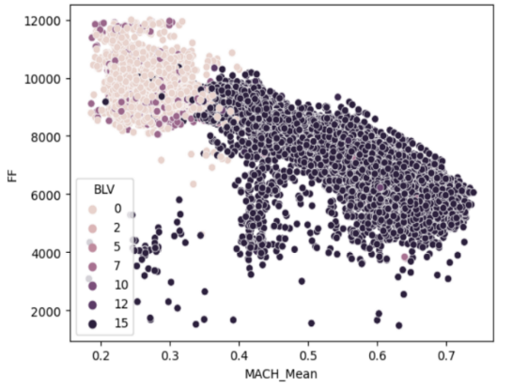
Fig. 5. Bleed Air Valves vs FF
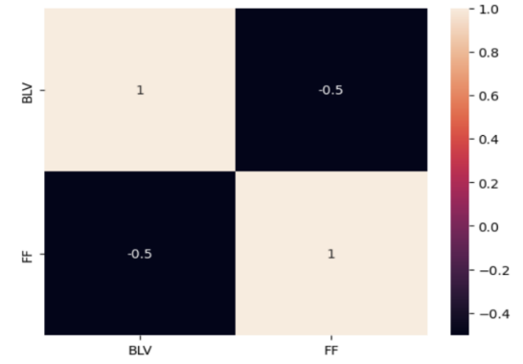
Fig. 6. Bleed Air Valves vs FF

Additionally, a correlation between the aircraft's MACH speed and BAV setting during climb was shown in Figure 6. As MACH speed increased, the BAV setting also increased, indicating that optimizing the BAV setting based on the current MACH speed could lead to reduced fuel consumption during climb.

The optimization process involves considering altitude, engine power settings, and evaluating the BAV setting. The use of bleed air can help offset the decrease in engine efficiency caused by the lower air pressure and temperature during climb, resulting in a lower fuel flow rate. The study also revealed that the use of bleed air can help to cool the engine and reduce the impact of the lower air pressure and temperature on engine efficiency.

Furthermore, the results of the analysis indicated a complex relationship between MACH speed, BAV setting, and fuel flow rate during climb. The study rejected the null hypothesis and indicated the alternate hypothesis. In conclusion, the optimization of the BAV setting based on MACH speed during climb can lead to significant fuel savings and improve the efficiency of the aircraft.

After several insights were derived from the analysis of Figure 7, the relationship between Thrust Mode and fuel flow rate during the climb phase of flight was studied. Based on the analysis of flight data recorder data, it was found that MACH speed, thrust mode, and fuel flow rate are interrelated during this phase. It was observed that as the MACH speed increased from 0.2 to 0.8, the thrust mode also increased from 1 to 11, indicating a need for more engine power to maintain altitude. However, despite the increased engine power, the fuel flow rate decreased as thrust mode and MACH speed increased, which indicates that higher thrust settings result in more efficient engine operation.

Analysis - Thrust Mode vs FF during Climb Phase

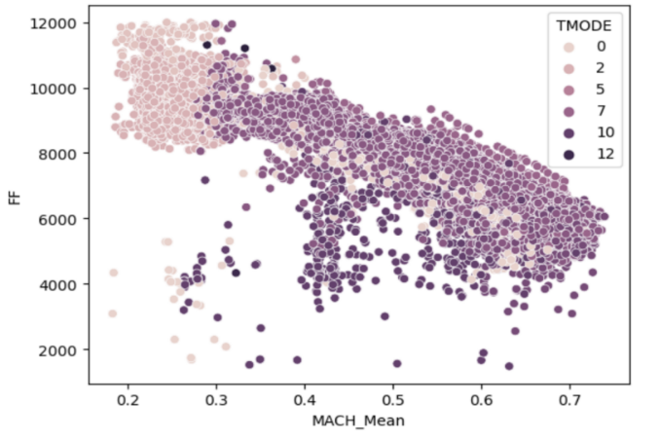
Fig. 7. FF Thrust Mode vs FF during Climb Phase

Further study of the relationship between MACH speed, thrust mode, and fuel flow rate during the climb phase of flight can help optimize fuel flow rate. To achieve maximum fuel efficiency without compromising flight performance, different thrust modes can be utilized for different flight phases. For example, Derate and Flex thrust modes can be used during takeoff to save fuel without sacrificing takeoff performance.

The Approach thrust mode can be used during landing to reduce fuel consumption during the descent and approach phases. The MCT and MCT modes can be used during the climb phase to achieve optimal engine efficiency while maintaining a safe ascent rate. Finally, the MCT mode can be used during flight to balance fuel efficiency and speed. Additionally, the reverser thrust mode can be used during landing to slow down the aircraft and reduce the need for excessive braking, which also saves fuel.

In conclusion, it was revealed that the relationship between thrust mode, fuel flow rate, and MACH speed is complex, with multiple factors influencing engine efficiency during the climb phase of flight. The optimization of fuel flow rate through the adjustment of thrust mode based on various flight parameters can result in significant fuel savings without compromising flight performance.

- Model Comparative Analysis

After the performance of multiple regression models was evaluated, the results were analyzed and compared based on their performance on the validation set as shown in Table 2.
Table 2. Base model comparative table
Model | MAE | MSE | RMSE | R2 Score | Adjusted R2 Score
Linear Regression | 322.29 | 225203.62 | 474.56 | 0.9595 | 0.9595
Bayesian Regression | 322.31 | 225222.94 | 474.58 | 0.9595 | 0.9595
Lasso Regression | 330.83 | 234581.83 | 484.34 | 0.9578 | 0.9578
Ridge Regression | 322.35 | 225192.09 | 474.54 | 0.9595 | 0.9595
Decision Tree | 330.29 | 240756.57 | 490.67 | 0.9567 | 0.9567

Similar performance on the validation set was observed for the Linear regression, Bayesian regression, and Ridge regression models, with mean absolute errors (MAE) ranging from 322.2947 to 322.3503 and root mean squared errors (RMSE) ranging from 474.5562 to 474.5441. High R2 scores were obtained for these models, indicating that most of the variance in the target variable was explained.

Higher errors on the validation set were observed for the Lasso regression and Decision Tree models, with MAE ranging from 330.8342 to 330.2865 and RMSE ranging from 484.3365 to 490.6695. Additionally, these models had lower R2 scores compared to the other models, indicating less explained variance in the target variable.

An Artificial Neural Network (ANN) model was evaluated on the validation set, which showed the best performance with an RMSE of 204.2667 and an R2 score of 0.9925. This indicates that the ANN model has high predictive power and can accurately predict the target variable. It is important to note that this model may be computationally expensive and may require additional data preprocessing steps.

Overall, it was observed that the ANN model outperformed the other regression models on the validation set, while the Lasso regression and Decision Tree models showed lower performance. Linear regression, Bayesian regression, and Ridge regression models showed similar performance and may be good alternatives if the computational cost of ANN is an issue.

- Conclusion
The proposed ANN model showcases a noteworthy enhancement in its ability to predict fuel flow rate during the climb phase of a Boeing 676 aircraft. This advancement has the potential to drive improved fuel management and optimization strategies within the aviation industry. This research contributes meaningfully to the existing knowledge landscape concerning data-driven fuel consumption prediction, offering valuable insights that can guide future investigations aimed at bolstering aircraft fuel efficiency. Opportunities for refinement lie in the realms of feature selection and accounting for human response time, as these factors can impact aircraft fuel flow rate. Subsequent studies could delve into these areas, further refining the accuracy of aircraft fuel flow rate prediction. This refinement, in turn, could lead to reduced operational costs for airlines and environmentally conscious practices.

- References

- Baumann, S., Klingauf, U.: Modeling of aircraft fuel consumption using machine learning algorithms. CEAS Aeronautical Journal. 11, 277–287 (2019). https://doi.org/10.1007/s13272-019-00422-0.
- Singh, J., Sharma, S.K., Srivastava, R.: Managing fuel efficiency in the aviation sector: challenges, accomplishments and opportunities. FIIB Business Review. 7, 244–251 (2018). https://doi.org/10.1177/2319714518814073.
- Chati YS, Balakrishnan H (2017) A Gaussian process regression approach to model aircraft engine fuel flow rate. ICCPS ’17: Proceedings of the 8th International Conference on Cyber-Physical Systems. https://doi.org/10.1145/3055004.3055025
- Velásquez-SanMartín, F., Insausti, X., Zárraga-Rodríguez, M., Gutiérrez-Gutiérrez, J.: A Mathematical Model for the Analysis of Jet Engine Fuel Consumption during Aircraft Cruise. Energies. 14, 3649 (2021). https://doi.org/10.3390/en14123649.
- Oh, E., Kim, H.-K., Jeon, D.: A Model for Estimation of Fuel Consumption during Aircraft Taxi Operations. Conference: 2018 IEEE/AIAA 37th Digital Avionics Systems Conference (DASC). (2018). https://doi.org/10.1109/dasc.2018.8569844.
- Zhen, P., Chi, C., Zhang, J.: A Model of Fuel Consumption Estimation and Abnormality Detection based on Airplane Flight Data Analysis. Conference: 2018 IEEE/AIAA 37th Digital Avionics Systems Conference (DASC). (2018). https://doi.org/10.1109/dasc.2018.8569796.
- Zhang, H., Wang, X., Chen, X.: Support Vector with ROC Optimization Method Based Fuel Consumption Modeling for Civil Aircraft. Procedia Engineering. 99, 296–303 (2015). https://doi.org/10.1016/j.proeng.2014.12.538.
- Amrutha, K.N., Bharath, Y.K., Jayanthi, J.: Aircraft Engine Fuel Flow Parameter Prediction and Health Monitoring System. Conference: 2019 4th International Conference on Recent Trends on Electronics, Information, Communication & Technology (RTEICT). (2019). https://doi.org/10.1109/rteict46194.2019.9016703.
- Wang, X., Chen, J.: Aircraft Fuel Consumption Prediction Method Based on Just-In-Time Learning and Enhanced Fifitness Adaptive-Differential Evolution-Relevance Vector Machine. Conference: 2020 Chinese Automation Congress (CAC). (2020). https://doi.org/10.1109/cac51589.2020.9327259.
- Langton, R., Clark, C.S., Hewitt, M., Richards, L.: Aircraft fuel systems. Encyclopedia of Aerospace Engineering. (2010). https://doi.org/10.1002/9780470686652.eae463.
- Kim, J.-H., Kim, S.-K., Song, K., Yi, Y., Mavris, D.N.: Aircraft mission analysis enhancement by using data science and machine learning techniques. AIAA Aviation 2019 Forum. (2019). https://doi.org/10.2514/6.2019-3311.
- Luo, W., Zixuan, W., Chen, C.: An Aircraft Fuel Flow Model of Cruise Phase Based on LSTM and QAR Data, https://doi.org/10.1109/iscid51228.2020.00033.
- Mazraati, M., Alyousif, O.M.: Aviation fuel demand modelling in OECD and developing countries: impacts of fuel efficiency. OPEC Energy Review. 33, 23–46 (2009). https://doi.org/10.1111/j.1753-0237.2009.00161.x.
- Baumann, S.: Using machine learning for Data-Based assessing of the aircraft fuel economy. (2019).
- Kim, H.-J., Baik, H.: Empirical method for estimating aircraft fuel consumption in ground operations. Transportation Research Record. 2674, 385–394 (2020). https://doi.org/10.1177/0361198120961033.
- Schaal, S., Atkeson, C.G.: Robot juggling: implementation of memory-based learning. IEEE Control Systems Magazine. 14, 57–71 (1994). https://doi.org/10.1109/37.257895.
- Ye, L., Cao, L., Wang, X.: Evaluating Fuel Consumption for Continuous Descent Approach based on QAR data. Promet-traffic & Transportation. 31, 407–421 (2019). https://doi.org/10.7307/ptt.v31i4.2933.
- Zhu, X., Li, L.: Flight time prediction for fuel loading decisions with a deep learning approach. Transportation Research Part C: Emerging Technologies. 128, 103179 (2021). https://doi.org/10.1016/j.trc.2021.103179.
- Seymour, K., Held, M., Georges, G., Boulouchos, K.: Fuel Estimation in Air Transportation: Modeling global fuel consumption for commercial aviation. Transportation Research Part D: Transport and Environment. 88, 102528 (2020). https://doi.org/10.1016/j.trd.2020.102528.
- Mrazova, M.: Future directions of fuel efficiency in aviation industry. INCAS Buletin. 5, 71–86 (2013). https://doi.org/10.13111/2066-8201.2013.5.4.8.
- Kang, L., Hansen, M.: Improving airline fuel efficiency via fuel burn prediction and uncertainty estimation. Transportation Research Part C: Emerging Technologies. 97, 128–146 (2018). https://doi.org/10.1016/j.trc.2018.10.002.
- Li, G.: Machine learning in fuel consumption prediction of aircraft. Conference: Proceedings of the 9th IEEE International Conference on Cognitive Informatics, ICCI 2010, July 7-9, 2010, Beijing, China. (2010). https://doi.org/10.1109/coginf.2010.5599714.
- Los, A., Tiniakov, D., Makarova, L.: Information Analysis Of Modifications To Increase Fuel Efficiency In Regional Passenger Jets. IEEE. (2020). https://doi.org/10.1109/icmeas51739.2020.00028.
- Baumann, S., Klingauf, U.: Modeling of aircraft fuel consumption using machine learning algorithms. CEAS Aeronautical Journal. 11, 277–287 (2019). https://doi.org/10.1007/s13272-019-00422-0.
- Mazraati, M., Faquih, Y.O.: Modelling aviation fuel demand: the case of the United States and China. OPEC Energy Review. 32, 323–342 (2008). https://doi.org/10.1111/j.1753-0237.2009.00156.x.
- Singh, V.: Fuel consumption optimisation using structural equation modelling and genetic algorithm approach: The case of commercial aviation. European Transport. 78, 1–21 (2020). https://doi.org/10.48295/et.2020.78.2.
- Uzun, M., Demirezen, M.U., Tsourdos, A.: Physics guided Deep Learning for Data-Driven Aircraft fuel Consumption modeling. Aerospace. 8, 44 (2021). https://doi.org/10.3390/aerospace8020044.
- Horiguchi, Y., Baba, Y., Kashima, H., Suzuki, M., Kayahara, H., Maeno, J.: Predicting fuel consumption and flight delays for Low-Cost airlines. Proceedings of the ... AAAI Conference on Artificial Intelligence. 31, 4686–4693 (2017). https://doi.org/10.1609/aaai.v31i2.19095.
- Zhang, Q., Streets, D.G., Carmichael, G.R., He, K., Hong, H., Kannari, A., Klimont, Z., Park, I.S., Reddy, S.P., Fu, J.S., Chen, D., Duan, L., Lei, Y., Wang, L.T., Yao, Z.: Asian emissions in 2006 for the NASA INTEX-B mission. Atmospheric Chemistry and Physics. 9, 5131–5153 (2009). https://doi.org/10.5194/acp-9-5131-2009.
- Huang, C., Xu, Y., Johnson, M.E.: Statistical modeling of the fuel flow rate of GA piston engine aircraft using flight operational data. Transportation Research Part D: Transport and Environment. 53, 50–62 (2017). https://doi.org/10.1016/j.trd.2017.03.023.

